DOCUMENTATION FOR 8080
Additional information-
Source – gemini “
Yes, the 8080 requires a two-phase clock ($\Phi_1$ and $\Phi_2$). To answer your question directly: Yes, they run at the exact same frequency, but they are "out of phase" with each other.
Think of it like a person walking: your left foot and right foot move at the same speed (frequency), but they never hit the ground at the same time.
The Non-Overlapping Rule
The most critical requirement for the 8080 is that these two clocks must be non-overlapping. This means $\Phi_1$ must go to $0\text{V}$ before $\Phi_2$ begins to rise, and vice versa.
- Frequency: Usually between $500\text{kHz}$ and $2\text{MHz}$ (depending on the specific 8080 model).
- Voltage: Unlike modern chips that use $3.3\text{V}$ or $5\text{V}$, the 8080 clock pulses actually required a high swing of nearly $12\text{V}$.
Why two phases?
The 8080 uses these two phases to create a "bucket brigade" for data. Because the internal buses are shared, you can't have every component talking at once.
- Phase 1 ($\Phi_1$): Typically used to increment the internal state counters and set up addresses on the internal bus. It "prepares" the next step.
- Phase 2 ($\Phi_2$): Typically used for the actual data transfer or "latching." This is when a register actually opens its "gate" to catch the data sitting on the bus.
The "Asymmetric" Timing
While the frequency is the same, the duty cycle is usually different. In a standard 8080 setup:
- $\Phi_1$ is a very short pulse.
- $\Phi_2$ is much wider.
- There is a mandatory "dead zone" (delay) between them to ensure no two circuits are active at the same time, which prevents data collisions on that single 8-bit internal bus you saw in your diagram.
This complex timing is why almost every 8080 circuit board has a companion chip called the 8224 Clock Generator, which takes a single crystal frequency and splits it into these two specific, high-voltage phases for the CPU. “

The "Asynchronous" Illusion
The reason it might feel asynchronous is because of the Multiplexer (MUX) and Buffers:
- Reading (Asynchronous-like): When the Instruction Decoder selects a register to be read, the Multiplexer connects that register to the bus. This part is combinational logic—as soon as the "Select" lines change, the data flows out.
- Writing (Strictly Synchronous): To actually change the value inside a register (like or ), the chip must wait for the clock pulse to "latch" the new value in. Without that clock pulse, the register stays exactly as it was.

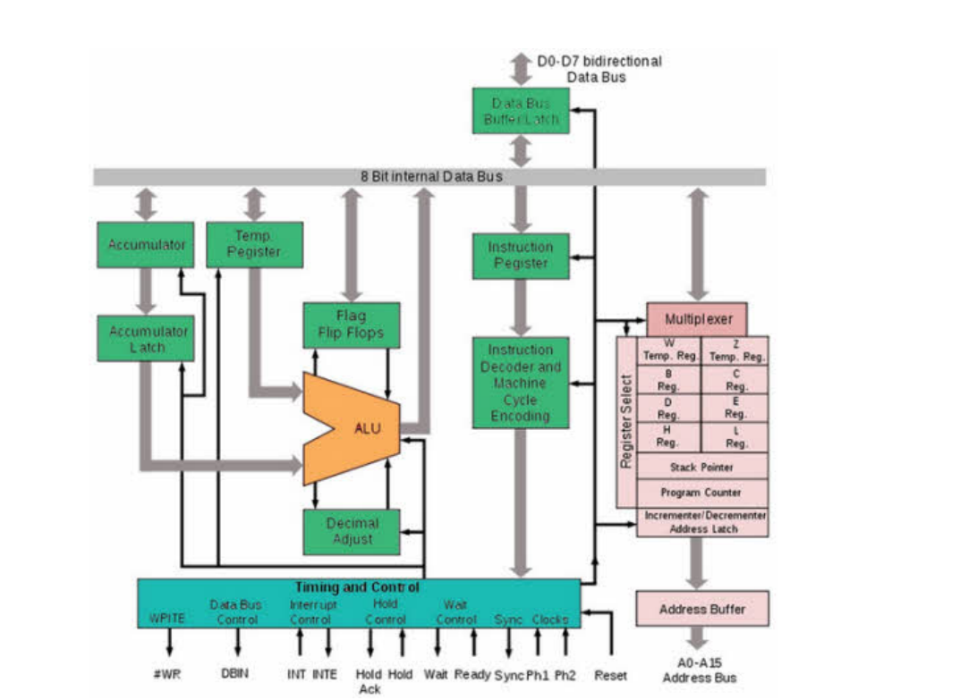
Signals to be given as an output-
Sync, DBIN,Write,Wait,Inte
Output-
Ready , Hold, HLDA, INT, reset
PC Should come from the memory itself , changed that.
1.Timing module-
produces timing signals which are given to the fetch module . it is fsm based . total 3t states make the machine cycle for fetch. the 4th state is the execute state. when it reaches this state it enables the instruction decode block so control signals(exe_start) for that are sent based on decoded opcode. when the execution completes exe_end becomes high so exe_start becomes zero.

2.Fetch-
only transfers data from 1 reg to another
3.instr_decode-
when exe_strt is high, it decodes the instr in the ir and send the appropriate control signals.

STARTED WITH REGISTER MOVE INSTRUCTIONS-
After detection of the opcode in instr_decode, it takes destination and source from there and goes to the reg_array. Here based upon the reg_operation various operations re multiplexed.

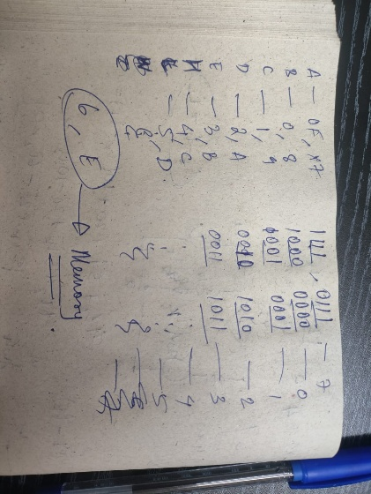 for choosing the address in the register array.
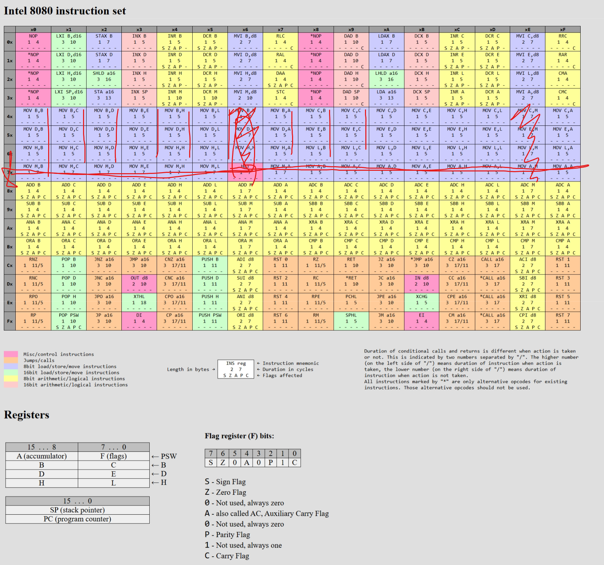source – last three bits of lsb destination -chosen on the basis of msb and lsb.
MEMORY LOAD and STORE-
Memory load is pard of the same case as above. Memory write is next case.
For memory load into the register, register destination is same as in the previous case, inside the instr_decode , addl_en is set to 1, which goes to fetch. Here , address latch gets mem_add which is coming from the reg_array. This is the 1st t state. Next, addl_en is again set to zero and read is set high, so data gets loaded in data inside the memory module, loading the data on the buffer, this is the 2nd t state. Now,this data is entered into the desination location so in the 3rd t state reg_operation is set as 1 so data transfer happens. In this same t state end_exe is also set high.
Memory store .
Storing data into memory. Source is coming from the same logic as above. And destination is also the same thing.
ALU-
Input1 is a and other is the one pointed in opcode
//1.ADD
//2.ADC
//3.SUB
//4.SBB
//5.ANA
//6.XRA
//7.ORA
//8.CMP
//9.rl without carry
//10.rr without carry
//11.rl with carry
//12.rr with carry
8080 donnot have any overflow flag so nothing is treated as negative or something. Msb of alu op will be signed flag.
4x- Bx done. Adi , etc to be done on Sunday.
Control signals-
Fetch-
DBIN,addl_en,IR_load
ALU-
Alu_en
Memory-
DBIN,Read,Write,addl_en,

Immediate instructions. After the three t cycle fetch, now in the 4th cycle, we will decode that it is an immediate type of instr, so we will first, load the current pc value(because it already incremented in state2 . in the 5th cycle, I will increment pc and load the pc value onto add_latch. In the 6th t cycle, we have to load the data from this onto the register (w/z). in the 7th state, we perform the operation , using the accumulator.
4th state- instr_decode imm_op=1;
5th cycle- inside state 4 in the timing, if(imm_op) dbin =1, inc pc = 1;
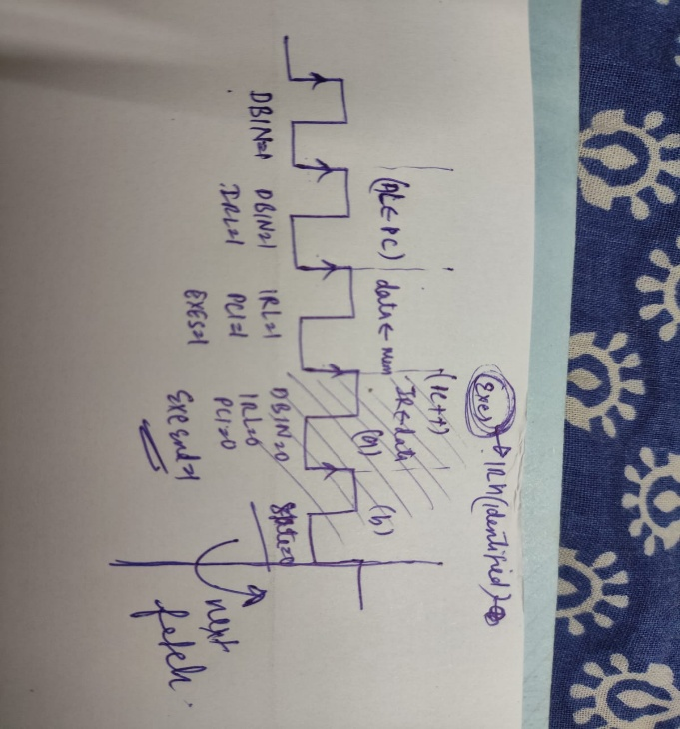
6th cycle- inside memory module, as dbin is high, data will get the value at address by add_latch. This will be entered into w/z
7th cycle. Alu operation.

INR, DCR
1st 3 – fetch,
4th decode- so alu ip1 – reg , alu ip 2 – 1; -- using inr_dcr signal for this
5th alu op-b ;

- Fetching the instruction using the pc.
Look in the timing module.
State 1, DBIN =1 so, 1st T state, add_latch will have the pc value.
State 2, DBIN =1 , IR_load =1, 2nd T state, data at address_latch location goes to data(buffer/data bus)
State3, data at data bus goes to IR, PC also increases
State4,execution .

- Register to register transfer-
In clock cycle a , effectively 4th t state, destination and source get their values.
In clock cycle b, data exchange happen. (5th t state)

- Memory to register
Already assuming that we reached a , - addl_en =1,
b(5th t state) mem_add will go to add_latch, read =1
6th t state – data will have the value, reg operation = 1, exe end =1 .
7 th t state- state = 0, data goes to its right place.

- Register to memory
We have reached a, addl_en =1,
5th state- reg operation =2 , mem_add will go to add_latch
6th state – data_write will get the value at register in the opcode. Write =1 , exe_end =1
7th state- data_write is written at the address add_latch.

- ALU(register) –
here i have use alu_done for exe_end

how does normal alu instructions happen like add b. 1st 3 states will go into fetch, 4th t state is only left. the problem here is i need one t state to give data to alu and next for its operation, so effectively i will need 5 t states but alu operation is a 4 state instruction ??????
chat gpt- The trick is: data transfer + ALU operation are overlapped, not separate T-states.
but in the 4th t state, i give values to two registers, destination and source . which go to reg array. which is again a module containing the register array. so only in the 5th clock pulse source and destination values will come in the reg array. So, I made reg_array combinational. Above no function is hampered due to that.
At a, alu_en =1, destination = always accumulator, alu_ctrl,source,destination, alu operation also performed, alu done made 1 so, exe – end. (4 t states)
Just for the alu result operation, handshaking is used between the reg array and the alu.

- ALU(mem) –
Reached a (4th t state), alu_mem =1, addl_en = 1.
5th t state – mem add will go to add_latch,read =1
6th state- alu_en =1, operation performed
7th state- alu_done = 1 so exit.

- ALU(imm-reg)
Reached 4th t state – imm_op =1, reg operation =3(not an issue, just some garbage value going to w/z), alu_ctrl gets value
5th state- dbin =1; inc pc.
6th state- taken pc value onto the add_latch. Dbin =1,imm_done=1;
7th state, data gets the value from the address pointed by add_latch. Alu_en . exe_end=1; imm_op = 0;

Yes, practically:
- Immediate data is first stored in a temporary register (often W/Z in designs)
- Then A and that register go to ALU
👉 But:
- W/Z is not fundamentally required by architecture
- It’s just an internal holding register
operand_reg <= data_from_memory; // could be W/Z
alu_out = A + operand_reg;
A <= alu_out;

- External RAM/ROM was slow
- CPU had to:
  - Fetch
  - Hold data
  - Then process
👉 Temporary storage (like W/Z) helped decouple memory from ALU timing

💡 6. Pin limitations
- Limited number of pins
- Multiplexed buses
- Minimal control lines
👉 Internal buffering (W/Z) helped manage this complexity

Why different fetch cycle ? because normal fetch cycle should take 3 t states, but here I am taking 2 t states. As I am incrementing pc in the 2nd state itself unlike how it is conventionally done.

4th – imm_op=1; alu_ctrl will get its value.
5th- dbin=1, pc_inc =1;
6th – add_latch gets the pc. Pc++, dbin =1; imm_done =1
7th – data will get value from the memory. Alu_en =1, imm_op=0; alu-mem=1;exe_end =1;

- INR , DCR
source <= {0,(IR_h[2:0]<<IR_h[2:0])+IR_l[3]};

4th t state. – assigns alu_ctrl, source. Alu en= 1, inr_dcr = 1; alu operation.
5th state- exe_state.

- INR-DCR (Mem)-
Fetch data like done in mem_alu. Then also write back .
4th – addl_en=1
5th – read =1 , add_latch will get the value stored in mem_add.
6th - data will get the value. ALU_en=1, so operation will happen, alu_done=1. (alu_done will be 1 until alu_en is high)
if alu done, then then write it back in the memory. // here I am using the temporary register w/z
7th – reg operation =5
8th data_write gets the value. Write =1
9th data gets written. To the same address from previous machine cycle. Exe_end =1
10th end

- MVI reg,data
4th state- imm_op=1;
5th state-Dbin=1 , pc inc=1;
6th state= pc will be stored in the add latch, pc incremented , imm_done=1, dbin =1
7th state- data will get the value of data at location add_latch.data moved to destination, exe_end.
- MVI mem, data.
4^{th-} made imm_op =1
5th dbin=1,pc_inc=1;
6th pc will be stored in the add latch, pc incremented , imm_done=1, dbin =1
7th data bus gets its value, mem_add already has the address. If(imm_done)- addl_en=1, reg_operation =100
8th mem_add stored in add_latch, so data goes to data_write, write =1
9th data written at the add_latch location. Exe_end =1
10th state =0.

- LDAX R
3 things are to be done . first , send the address to mem_add, then to add_latch. For this,I have to make addl_en . second, this data to be written on the databus(data). For this I have to make read high. 3rd write the data onto a.
4th – st_ld =1, addl_en=1;
5th – add_latch gets mem_add. Read =1; addl_en =0;
6th – data will get the value . read =0; addl_en=0; st_ld=0; end_exe =1; reg_operation=0110.
7th – a gets value. State=0, next state , new instr.

- STAX R
Again 3 things, 1st give add_latch the add_mem value .
Send value at acc to data_write.
3rd write the data onto mem[add_latch].

4th. - st_ld =1, addl_en=1
5th add_latch gets mem_add. Reg operation = 101
6th data_write gets the value at a. write =1; end exe=1;
7th data gets written.

- STA ---- here I am using the w/z pair (not visible to programmer)
3 fetches from the instr_mem. To do something similar to imm_op. Store contents of a to memory address fetched during the instruction. we are storing a at the address contained by {pc+2, pc+1} in the instr mem. 1st load the pc 1 at some location and then pc 2 , then load that into mem_add. Then addl_en, so that address comes on the add_latch. 1st fetched pc is lsb and second msb
4th- imm_op <=1;
5th- DBIN=1; pc_inc =1;
6th- add_latch – pc ; pc++; dbin =1; imm_done =1;
7th – data will get the lsb. Reg_operation
8th – z will get the value of data. Imm_op <=1;
9th – Dbin =1; ,,,,,,,,,,
10th - ;;;;;;;
11th – reg operation ;
12th – reg_operation executed now; mem_add will get the address. Addl_en <=1;
13th- write =1 ; exe end =1

- LDA-
Same as above, just change at step2
  - At the 12th state. Addl_en so loaded the address onto the add_latch
  - Add_latch gets its value. Read =1; exe_end =1; making this read combinational in the reg arrya or it would take more reads.
  - Data gets the value on the 14th t stat. at this point, state=0

- INX /DNX–
First send the lsb to alu. Then check for the carry/borrow flag. Now , if the carry temp reg is one, add this to the msb. Take 5 t states .
4th – ALU_en=1; source will get its value, accordingly. inx_dnx flag goes to alu, so in this same t state , temp_flag reg will get its value.
5th – Alu en =1 , source +1 ,exe end .

yes, INX/DCX use a dedicated 16-bit increment/decrement path, and DAD doesn’t because of hardware cost vs. usage trade-offs in the Intel 8080.
That’s a very simple operation in hardware:
- No second operand muxing
- No flag logic (8080 doesn’t update flags for INX/DCX)
- Just a ripple incrementer/decrementer
👉 Hardware for this is:
- Much smaller than a full adder
- Very fast (pure combinational carry chain)
So designers said:
“We’ll add a tiny 16-bit incrementer block—it’s cheap and very useful.”

So I am writing directly in the instr decode , {msb,lsb} = {msb,lsb} +/- 1
And at the same time, making exe_end =1 . as the logic is purely combinational, writing it in the combinational block of the reg_array.

- DAD – Add register pair to hl . carry flag is affected. 1st ill add the lsbs by making the destination and ource according(obviously L will be the source and destination will come from the opcode.)
4th – alu_en . dad <=1 ; values given to source and dest.
5th – registers got the value, they perform the operation and save alu_op into gpr[source] . reg_operation <=111 , alu__en =0;
6th- register source gets the value. Changed the value of source and destination now. Alu_ctrl = adc/sbb. Alu_en =1
7th – alu_en =0 ; reg operation 111. State_waste ==2 . exe end , dad =0

- LXI- load the 16bit immediate data (not address) into register pair. So similar to mvi but twice.
4th state – imm_op =1.
5th – dbin =1 , pc_inc=1;
6th – add_latch gets the pc value. Pc++ . dbin =1 . imm_done = 0(as lxi=1&&lxi_add = 01). Case =0.
7th – data gets the value stored at the address. Reg operation 1. Destination = add1(lxi_add=1). Dbin =1 , pc_inc =1
8th- data goes to the definite location. Dbin=1; pc++. Imm_done = 1; (as lxi=1 && lxi_add= 2 ) .
9th – data gets written. Immdone is one so exe_end.
- SHLD and LHLD – a 16 bit address will be fetched like 2050, now at this address some data would be there , that would be given to l and at 2051 data will be given to H . This is LHLD . In shld , data from these registers have to go the these memory location just like normal store. Same as sta or lda logic twice.
1st fetch the the address same as in lda /sta then , under step 2 respective function.
4th- imm_op <=1;
5th- DBIN=1; pc_inc =1;
6th- add_latch – pc ; pc++; dbin =1; imm_done =1;
7th – data will get the lsb. Reg_operation
8th – z will get the value of data. Imm_op <=1;
9th – Dbin =1; ,,,,,,,,,,
10th - ;;;;;;;
11th – reg operation ;
12th – reg_operation executed now; addl_en =1;
13th – add_latch gets its value. read=1; Shld_lhld =1 . addl_en=1.
14th – data gets written. Reg operation= 001. inside the reg array. (mem add). Mem_add gets this value, for next store simultaneously.
15th- data is written into L. read =1;
16th- value comes at data. Reg operation=001, destination H. exe_end =1,

SIMPLIFING THE COMPLEX INSTR_DECODE NEST------
Simply, let the control come to the instr_decode. It will have a main_decoder and data_path. Main decoder, takes the whole ir and decode it, and outputs control signals for various operations. Main_decoder will be a combinational circuit which will get activated only at the 4th t state. Data_path will again have many modules instantiated to it, each doing its function based on the control signal.
Categorizing instructions based on their functions-
Category 1 - reg_mov : normal reg to reg transfer.
Category 2- reg_read.
Category 3- reg_write.
Category 4- misc_control
Category 5- alu
Category 6 -

